**OUTPUT SCREENS**

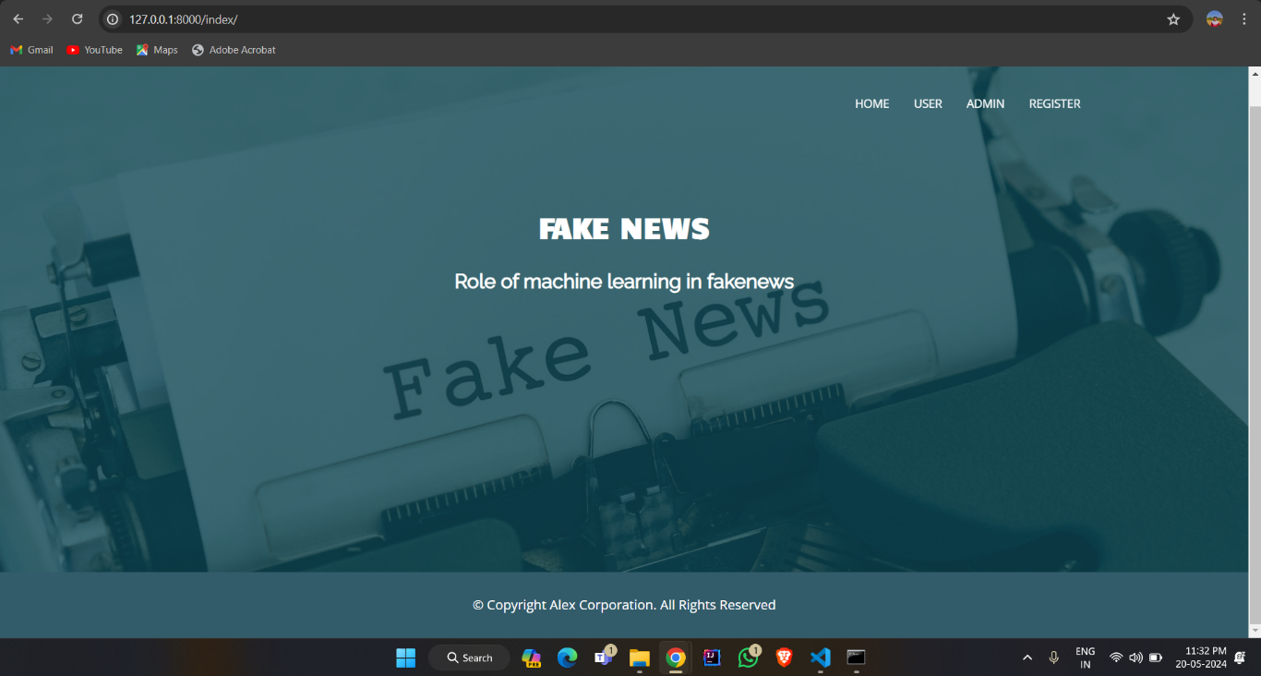

**OUTPUT SCREEN 8.1: Home Page**

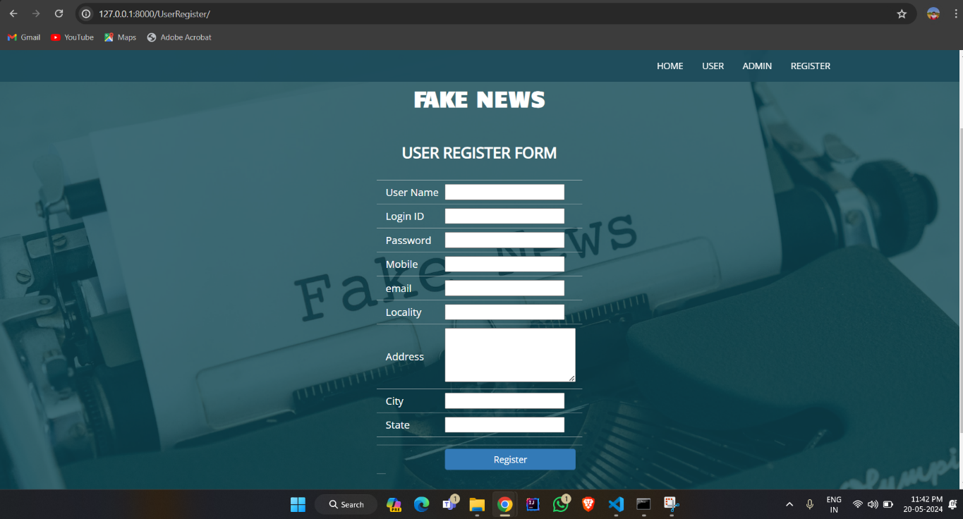

**OUTPUT SCREEN 8.2: User Registration Page**

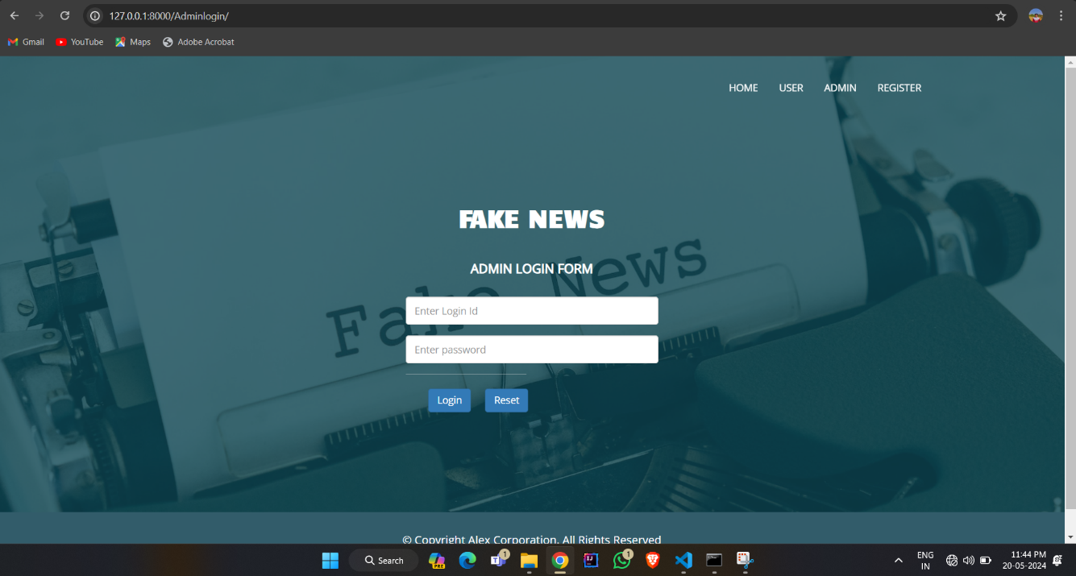

**OUTPUT SCREEN 8.3: Admin Login Page**

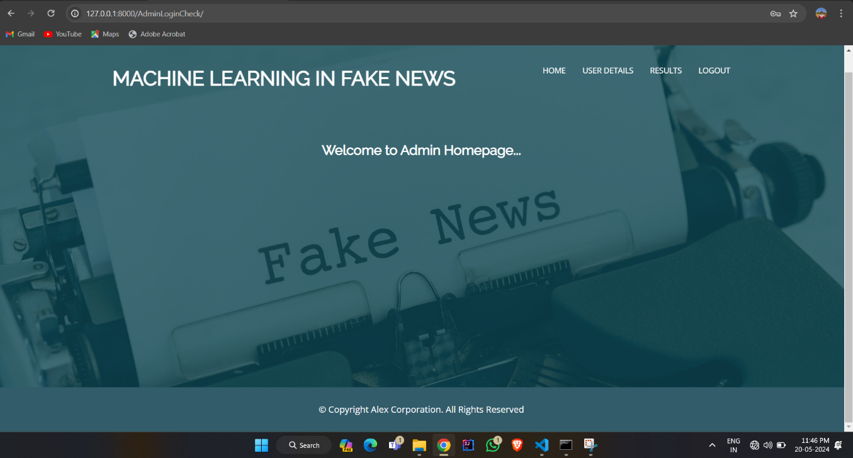

**OUTPUT SCREEN 8.4: Admin Home Page**

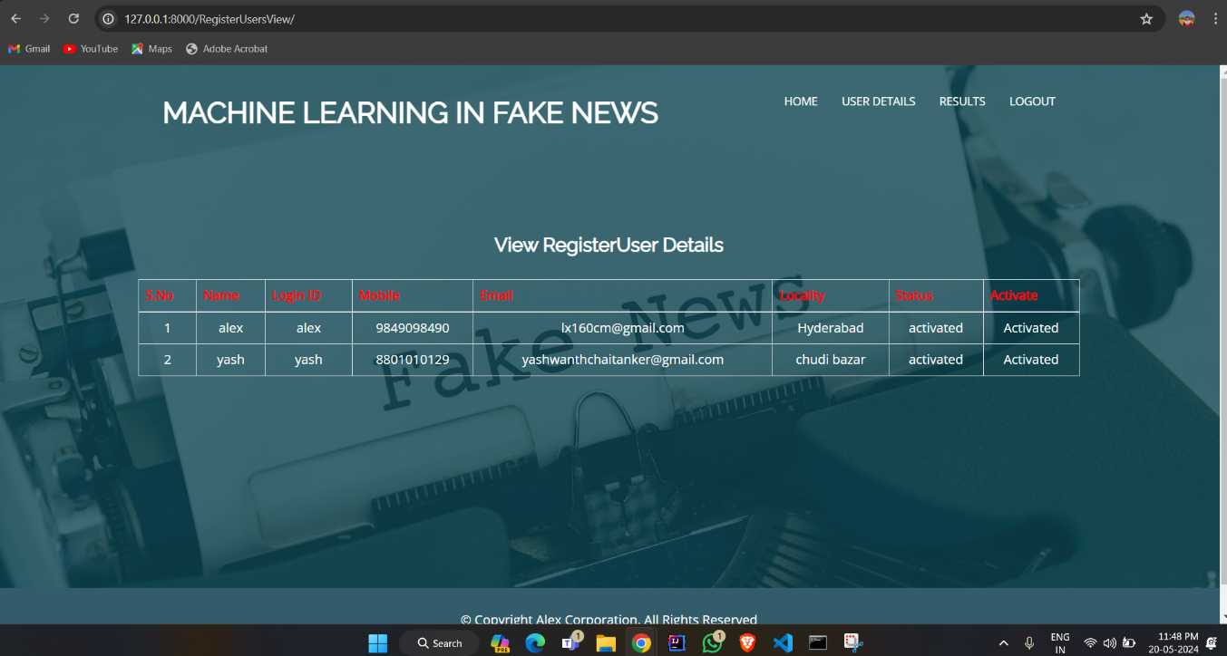

**OUTPUT SCREEN 8.5: Admin User Details Page**

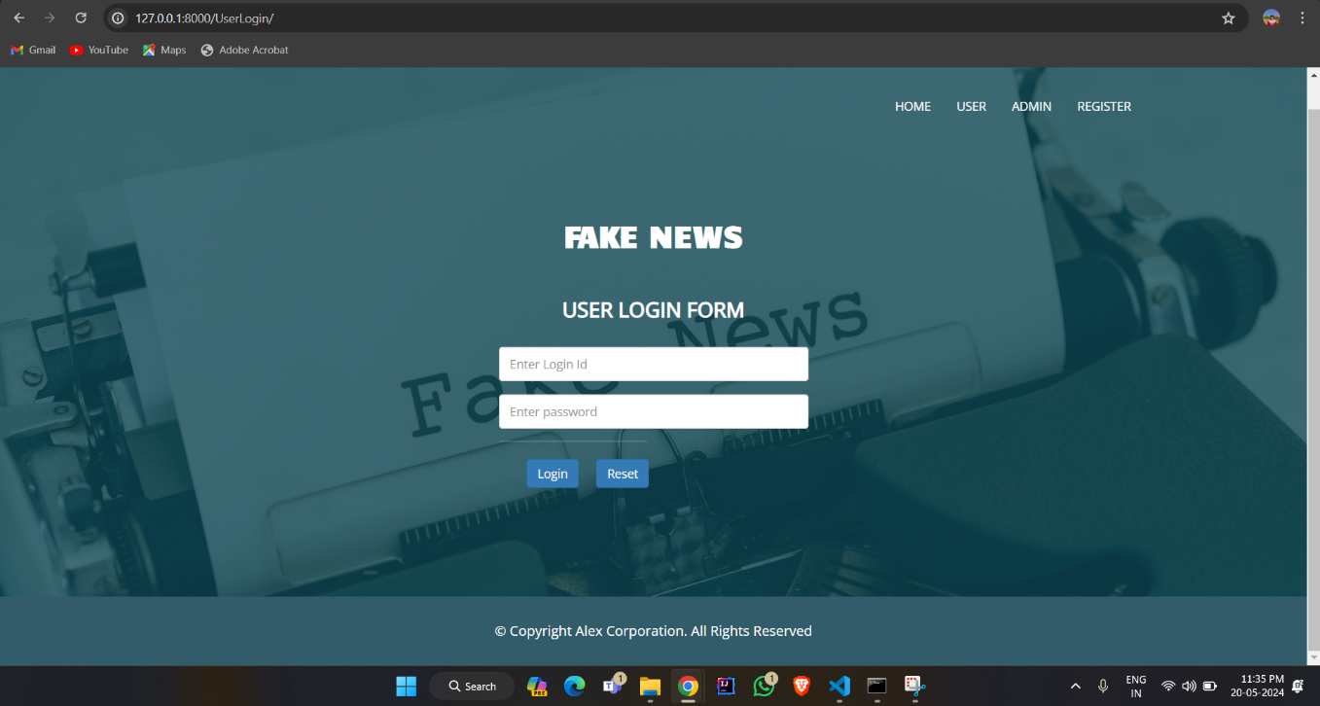

**OUTPUT SCREEN 8.6: User Login Page**

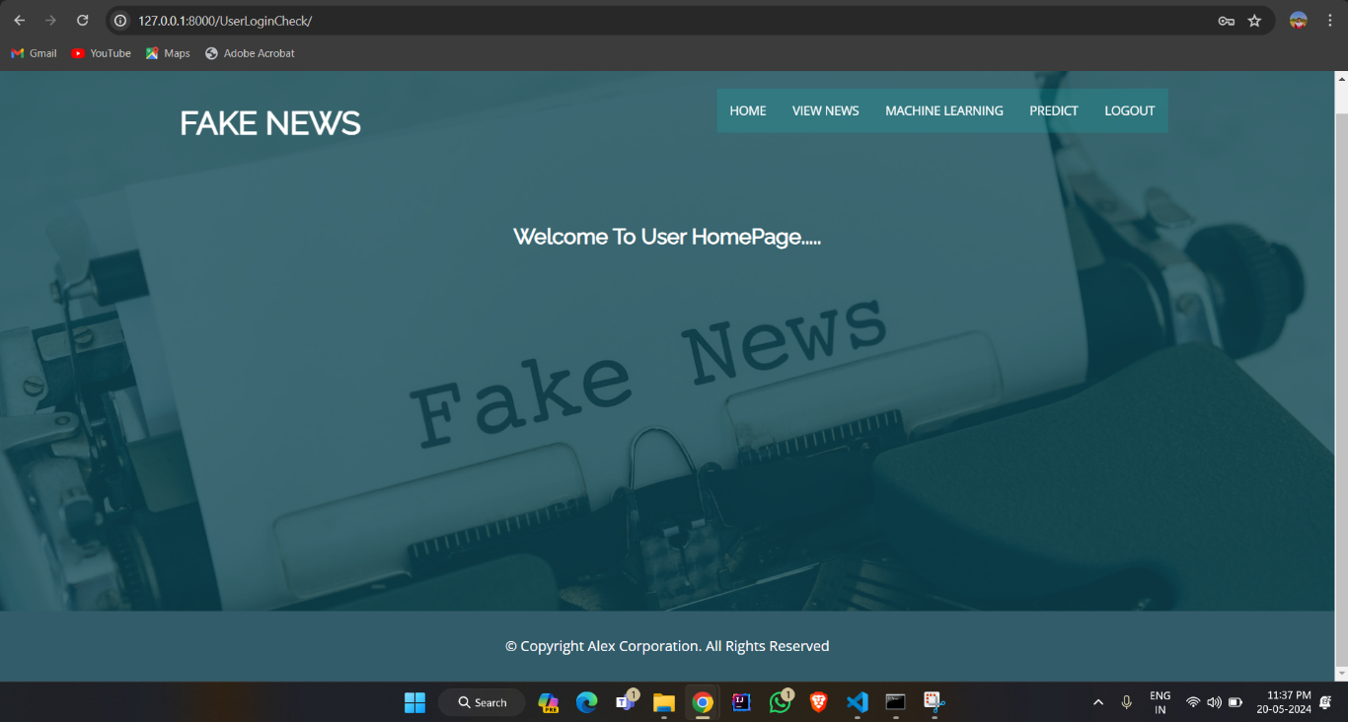

**OUTPUT SCREEN 8.7: User Home Page**

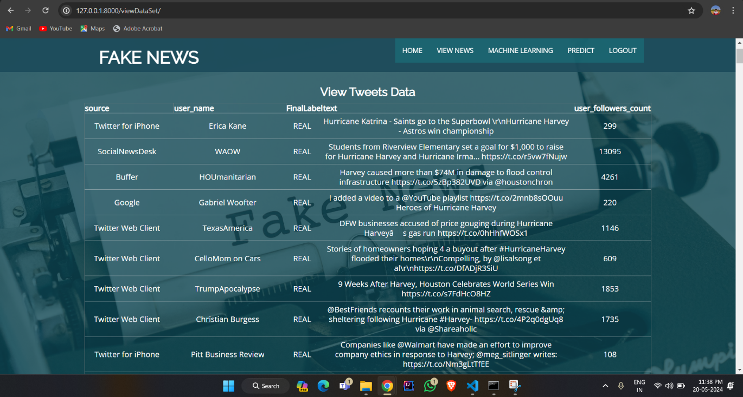

**OUTPUT SCREEN 8.8: User View News Page**

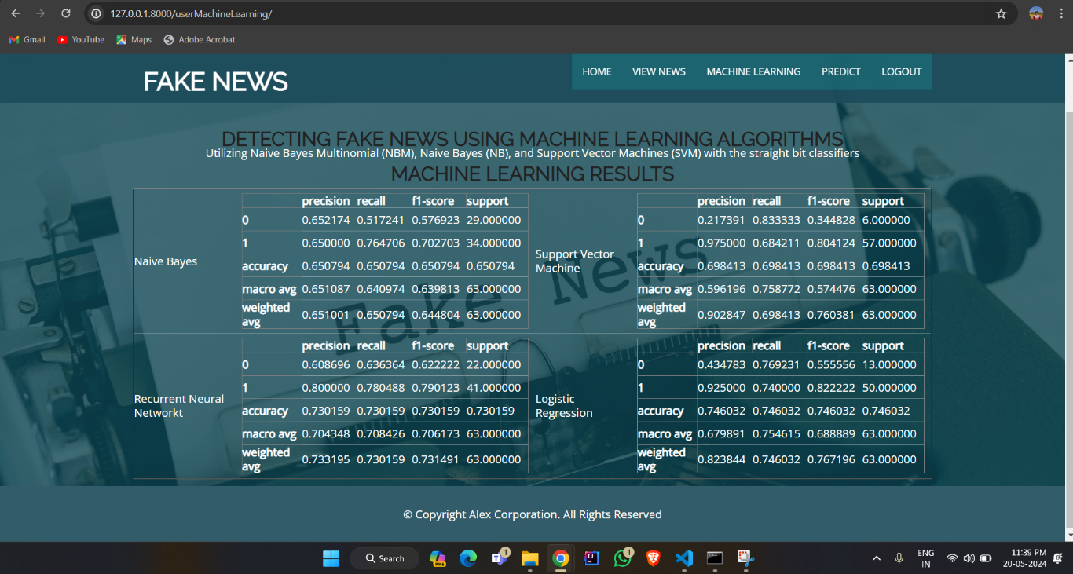

**OUTPUT SCREEN 8.9: User Machine Learning Results**

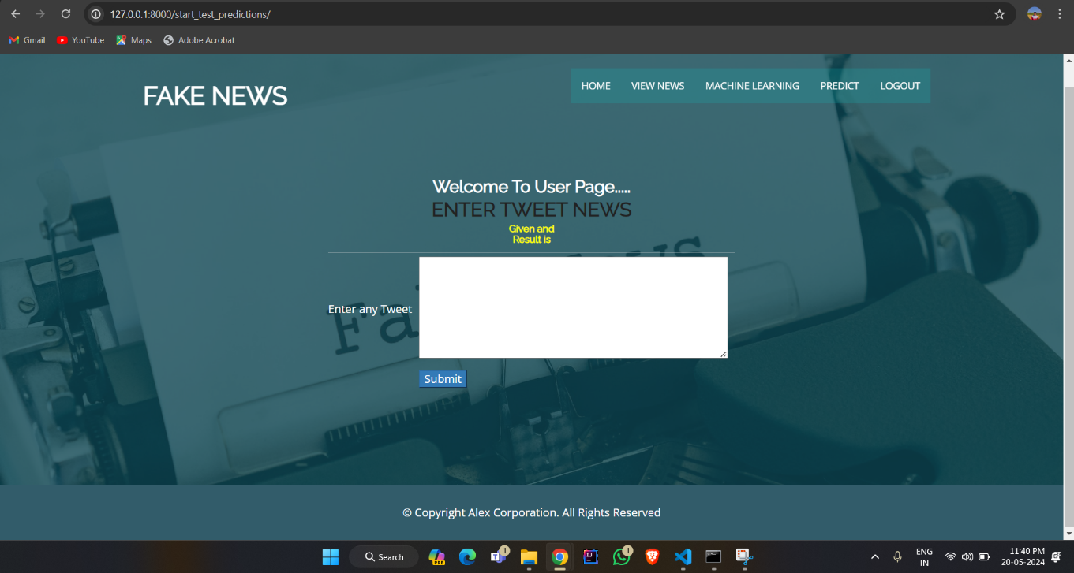

**OUTPUT SCREEN 8.10: User Predict Page**